Healthcare Fraud Prevention - Study Management Server
Deployment Guide

Revision History
Author | Revision Number | Date
TCSASSEMBLER | 1.0 | 12/1/2013

1. Submission Organization 3
2. Environment 3
3. Environment setup and configuration 3
3.1 Dependencies 3
3.2 Configuration 4
4. Verification 5
4.1 Start server 5
4.2 Create a normal user and login 5
4.3 Detail verifications 6
5. Resource Contact List 21

Submission Organization
This assembly is organized as follows:
- ./Healthcare Fraud Prevention - Study Management Server Deployment Guide.doc – this document.
- ./hfppnetwork - code of this assembly, including the python code/django templates/javascripts.
- ./mockserver - a server to mock NetworkNode services

Environment
The assembly was done and tested under folloing environment:
- Ubuntu 12.04.3 LTS 64-bit
- Python 3.3.2
- Django 1.6 https://www.djangoproject.com/
- jQuery 1.10.2 http://jquery.com/
- APScheduler 2.1.1 http://pythonhosted.org/APScheduler/
- WeasyPrint 0.19.2 http://weasyprint.org/

Browser used by verification is Firefox.

Environment setup and configuration

Dependencies
Install necessary development dependencies(if encountering with other missing packages, please install them):
sudo apt-get install gcc g++ libreadline-dev zlib1g-dev openssl libssl-dev libxml2-dev libxslt-dev sqlite3 libsqlite3-dev
reinstall python3 (to enable sqlite3)
cd /tmp
wget http://www.python.org/ftp/python/3.3.2/Python-3.3.2.tar.bz2
tar -xjf Python-3.3.2.tar.bz2
cd Python-3.3.2
make
sudo make install
download and install django 1.6
cd /tmp
wget https://www.djangoproject.com/m/releases/1.6/Django-1.6.tar.gz
tar -zxvf Django-1.6.tar.gz
cd Django-1.6
sudo python3 setup.py install
download and install setuptools(for WeasyPrint installation)
cd /tmp
wget https://pypi.python.org/packages/source/s/setuptools/setuptools-1.3.2.tar.gz
tar -zxvf setuptools-1.3.2.tar.gz
cd setuptools-1.3.2
sudo python3 setup.py install
down and install libffi(for WeasyPrint installation)
cd /tmp
wget ftp://sourceware.org:/pub/libffi/libffi-3.0.13.tar.gz
tar -zxvf libffi-3.0.13.tar.gz
cd libffi-3.0.13
./configure
make
sudo make install
download and instal WeasyPrint
cd /tmp
wget https://github.com/Kozea/WeasyPrint/archive/master.zip
unzip master.zip
cd WeasyPrint-master
sudo python3 setup.py install
download and install APScheduler
cd /tmp
wget https://pypi.python.org/packages/source/A/APScheduler/APScheduler-2.1.1.tar.gz
tar -zxvf APScheduler-2.1.1.tar.gz
cd APScheduler-2.1.1
sudo python3 setup.py install
download and install django-widget-tweaks(extension filters to add css class and change attribute)
cd /tmp
wget https://pypi.python.org/packages/source/d/django-widget-tweaks/django-widget-tweaks-1.3.tar.gz
tar -zxvf django-widget-tweaks-1.3.tar.gz
cd django-widget-tweaks-1.3
sudo python3 setup.py install

You can check Django-1.6 was sucessfully installed by running following python shell:
pyhon3
>>> import django
>>> print(django.VERSION)

Note that it's possible that your django doesn't run well. This is mainly because your python3 was not fully installed.

Configuration
There are following parameters to set in hfppnetwork/hfppnetwork/settings.py. Here are the sample settings that you need to adapt it to your environment.

Name | Description | Example
HFPP_NODE_HTTP_SERVICE_BASE_URL | Represents the base URL of HFPP Network Node HTTP Services | http://localhost:8443/NetworkNode/services(If the mock Network Node server listens on other IP, please change localhost to that IP)
There are following parameters to set in mockserver/hfppnetwork/settings.py. Here are the sample settings that you need to adapt it to your environment.

Name | Description | Example
DATA_REQUEST_URL | URL of the study management system for feeding back the data response from the mocked NetworkNode services | http://localhost:8080/data_response (If the study management server listens on other IP, please change localhost to that IP)

Verification

Start server
Notice: there are conflicts between the UI prototype and ADS, according to forum discussions, please refer to ADS if they are confilcting.
After configured settings.py, you can start web server by following commands:
cd hfppnetwork
python3 manage.py syncdb
python3 manage.py runserver 8080 (or python3 manage.py runserver IP:8080 if you run server in a VM and verify from windows)

You will be asked to create a super user during syncdb. Please follow instructions of django. The super user I created is:
username: admin
passowrd: admin

open another console
cd mockserver
python3 manage.py syncdb
python3 manage.py runserver 8443

mock server functionalties(mainly in views.py):
data_request:
study data request (triggered by ‘execute’ study) to partner 9 (see next section for test data creation) will be pending without response
study data request to partner 10 will be responded as denied
if last character of query string is ‘9’, then
study data request to partner 1, response with beneficiary claim data
study data request to partner 2, response with carrier claim data
study data request to partner 3, response with inpatient claim data
study data request to partner 4, response with outpatient claim data
(requirement of Prescription claim data xml mapping is still pending)
Otherwise, response with a simple result.

general_service:
It will always return with fix data

Create a normal user and login
Notice: login/logout is in scope of another assembly(Core assembly), please ignore related minor issues if you found
Open your browser, type url “http://localhost:8080/admin/” to create a normal user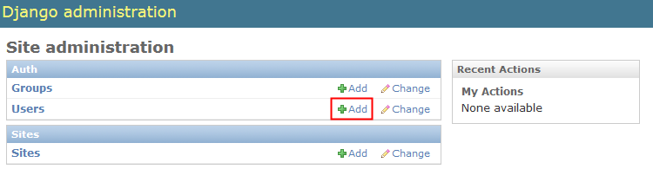
Create a normal user(user1/password) and click “Save”

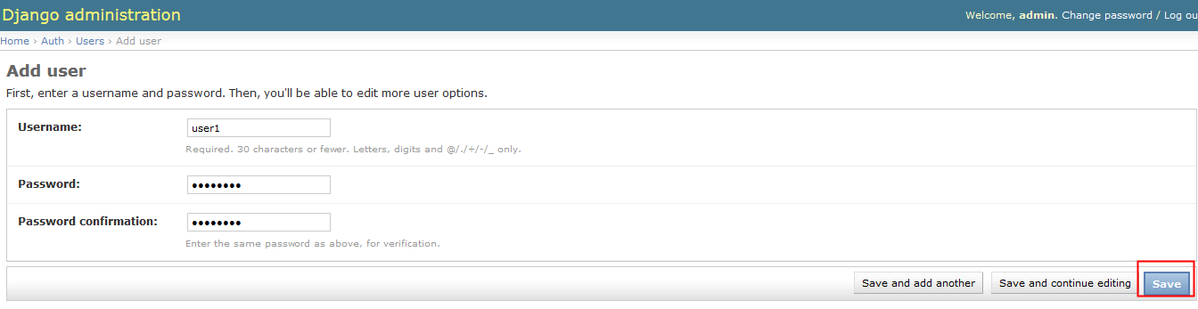

Open http://localhost:8080/login/ login with user1/password
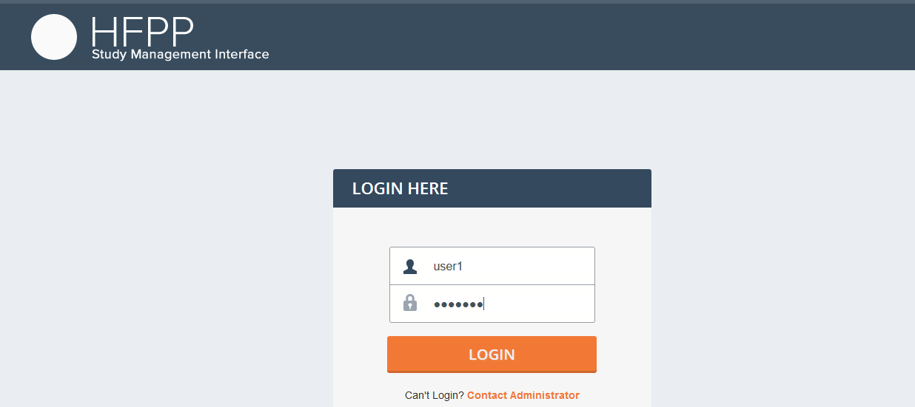

Detail verifications
After login
Open http://localhost:8080/test/create/ (end with ‘/’) to create test data(12 partners data)

Then you will see the list study view
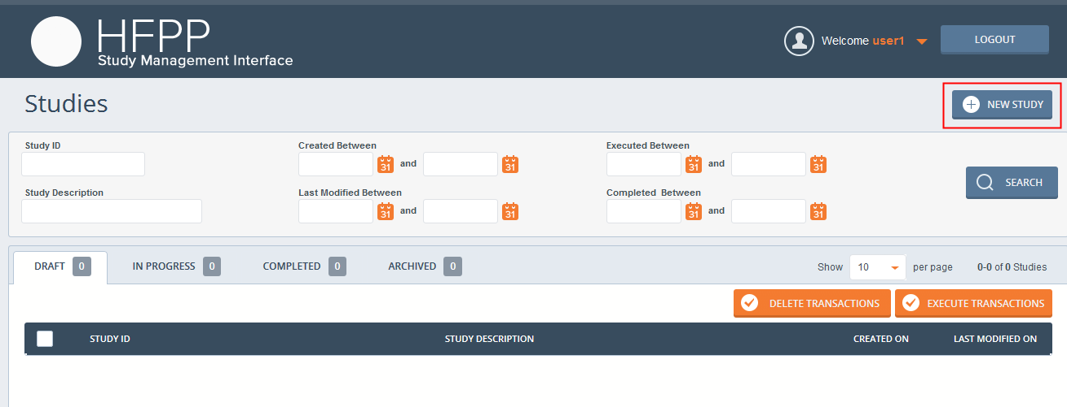

Click “NEW STUDY” to create a new study

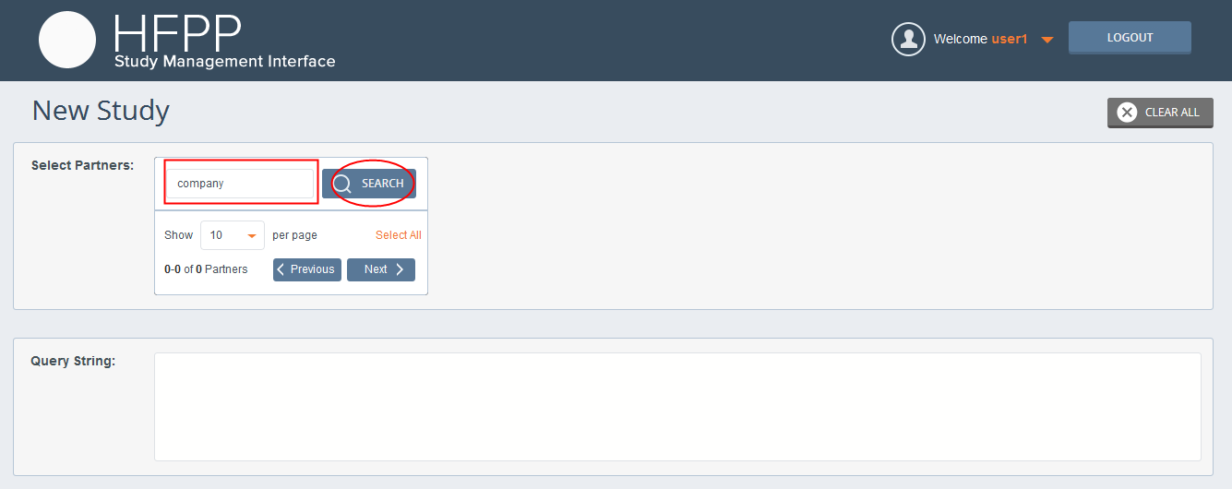
Input “company” in the search box and click “SEARCH” button
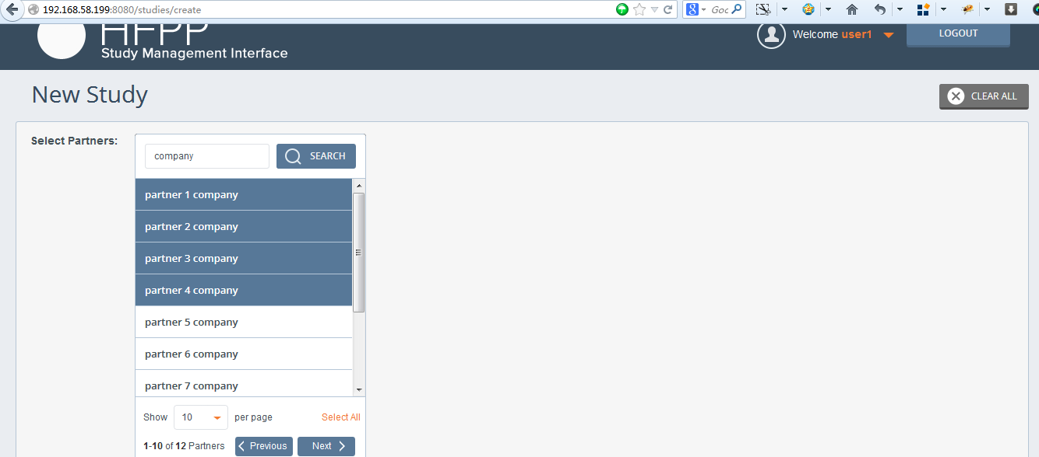
Select partner 1, partner 2, partner 3 and partner4 (for mock functionality), the create a (if without selection, will create a study for all the partners), then create query string “Payment less that $9” (ends with 9 for mock functionality)
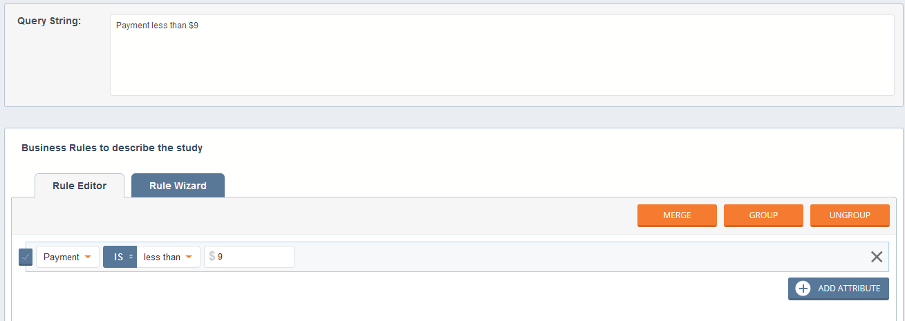

Click “Save as draft”
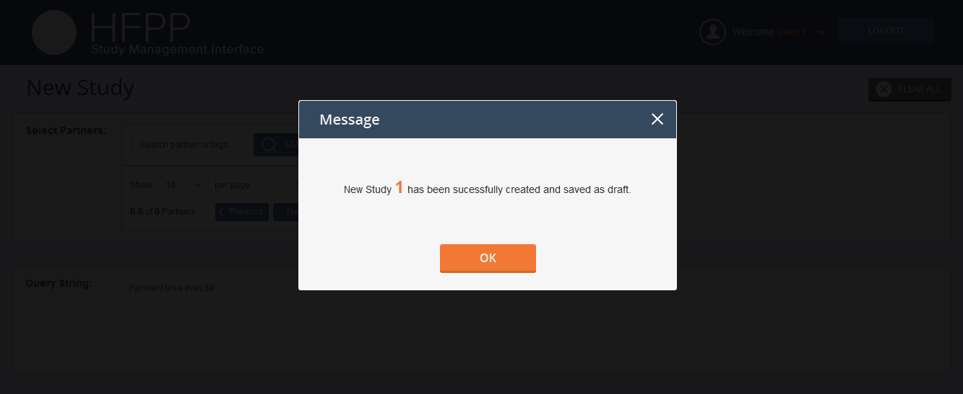
Click “OK”, it will redirect the study list view
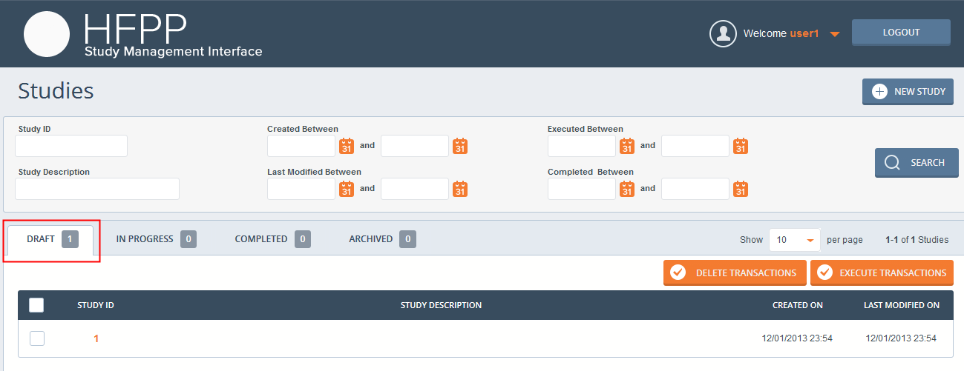
Go to create another study(without select any partner, query string ”Payment less than $1000”), but click “SAVE AND EXECUTE”
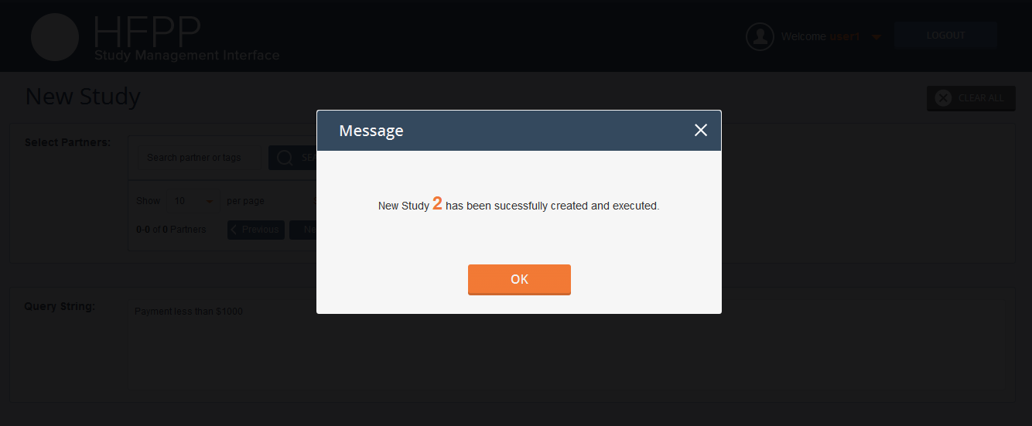
Click OK, it will redirect to the study list view (with tab “IN PROGRESS” active)
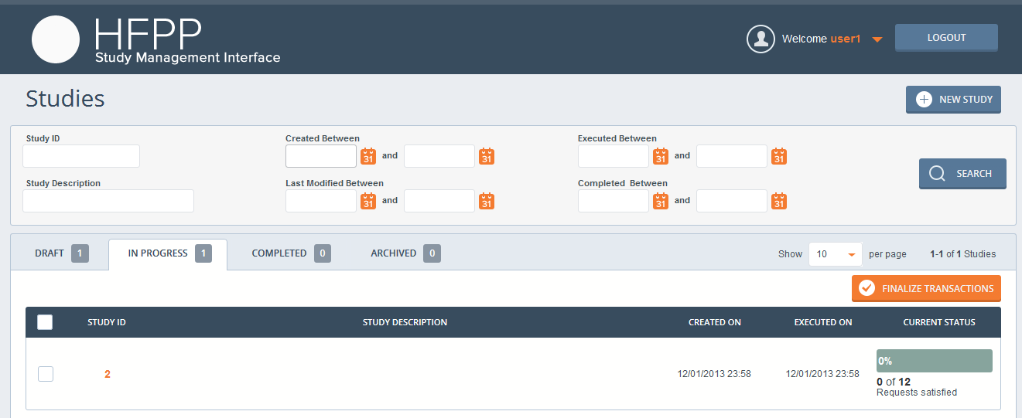
Create another study as draft, then go back to http://localhost:8080/study
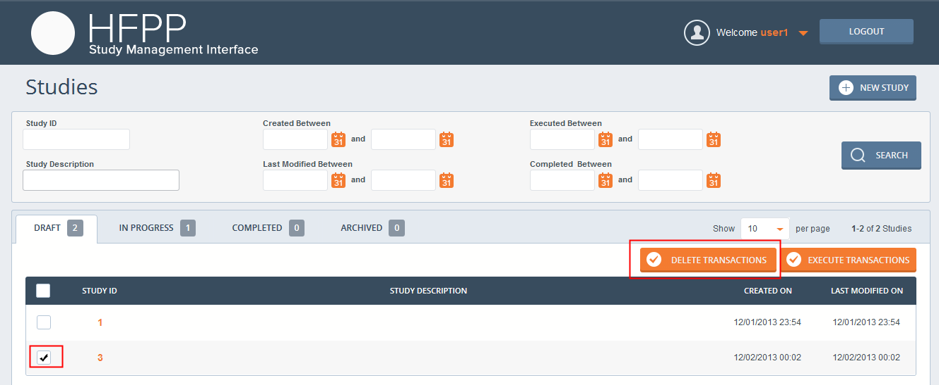
Select the newly created draft study, and click “EXECUTE TRANSACTIONS”, it will be deleted.
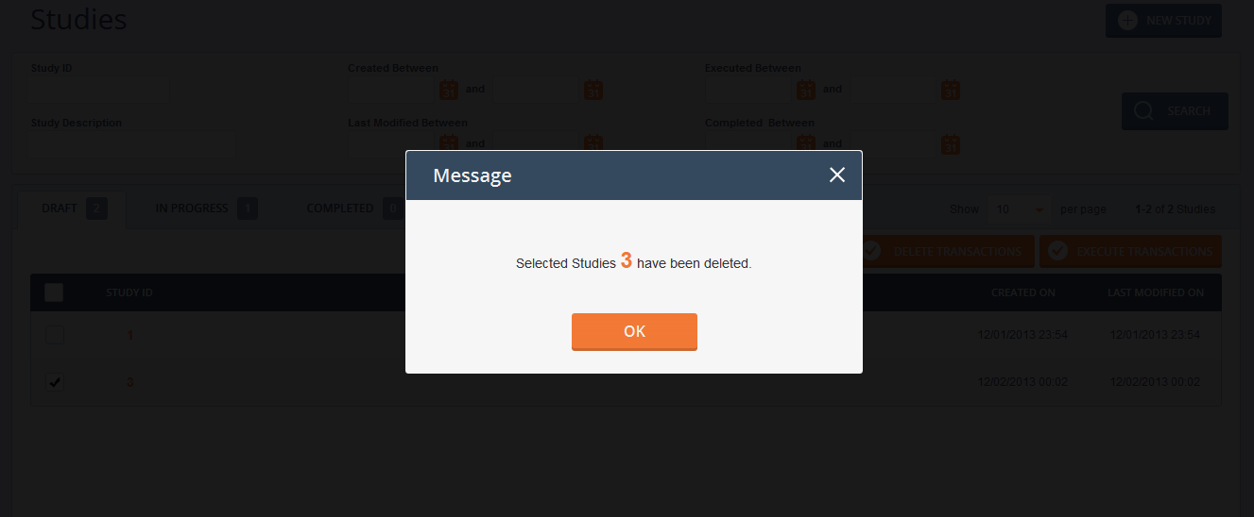
Select the first study, click “EXECUTE TRANSACTIONS”
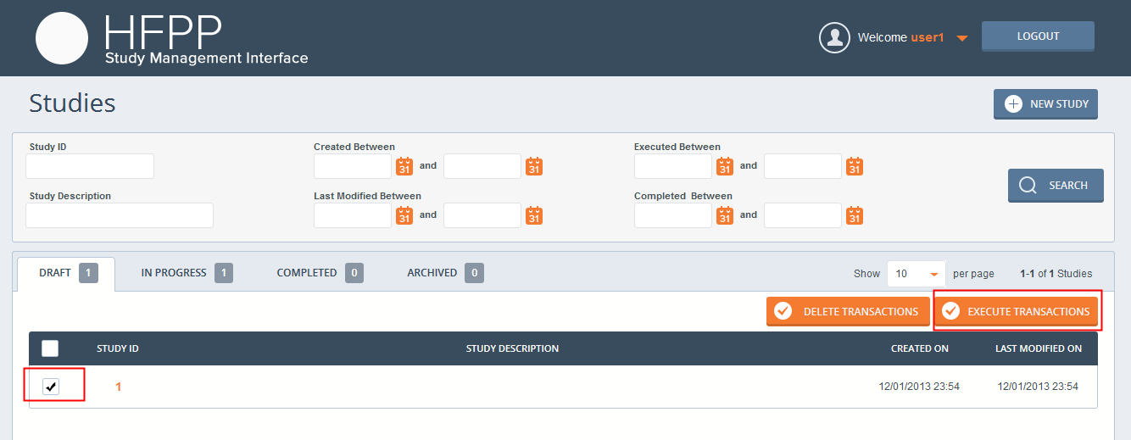
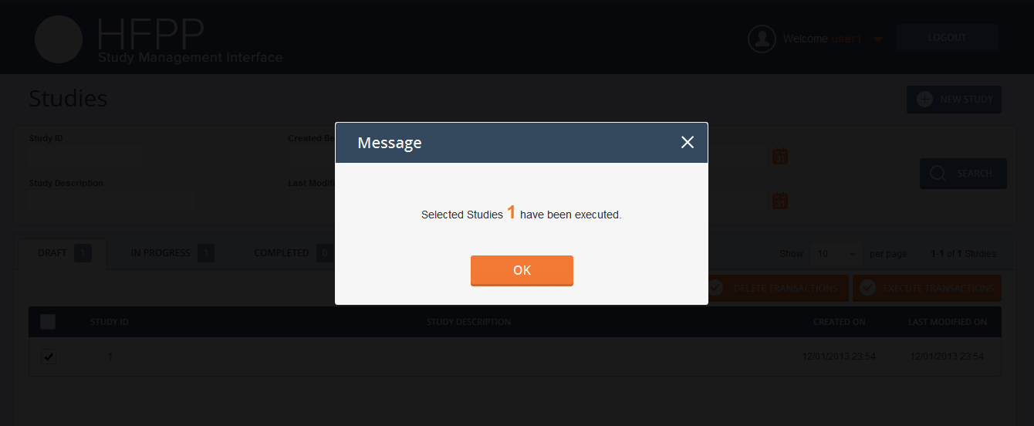
It will go to “in progress” tab
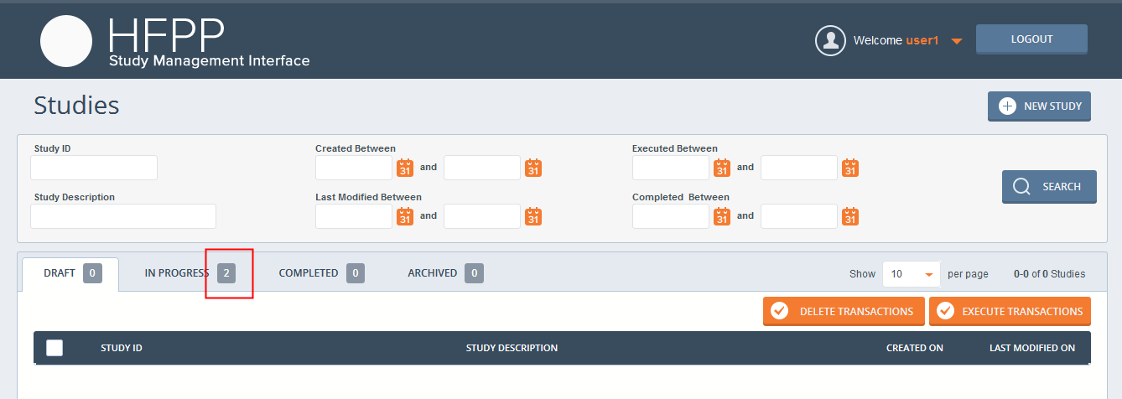
Create another study(without select any partner, query string ”Payment less than $1000”),
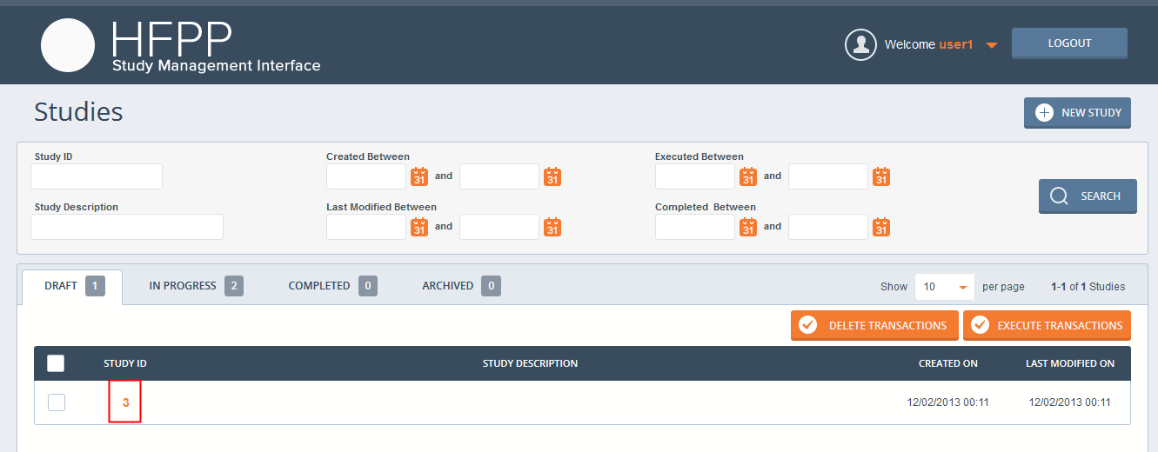
Click on the study id in the “DRAFT” tab of study list view, it will redirect to the business rule view
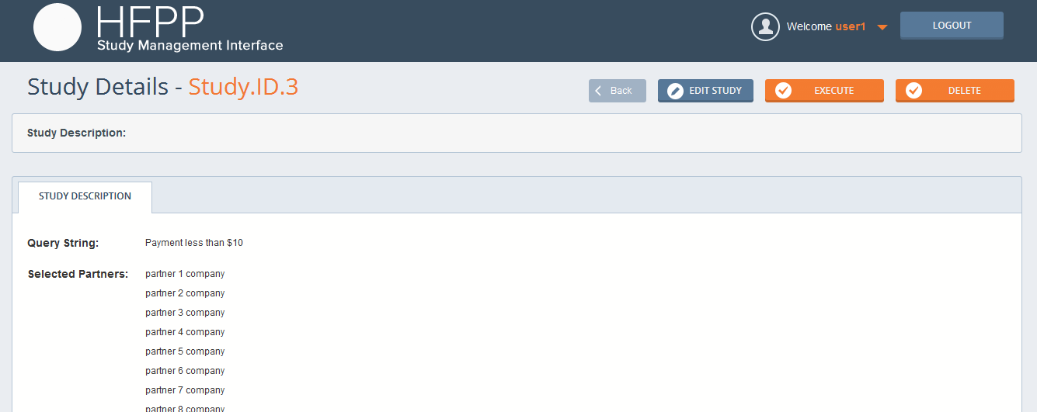
Click “EDIT STUDY” to edit
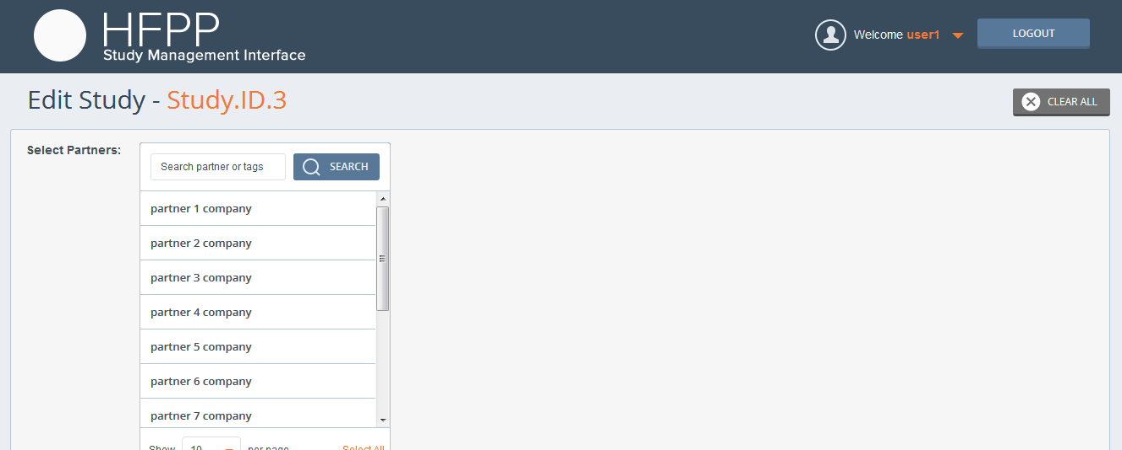
Select some partners and edit the query, then click “SAVE AS DRAFT” or “SAVE AND EXECUTE” (similar as create study)
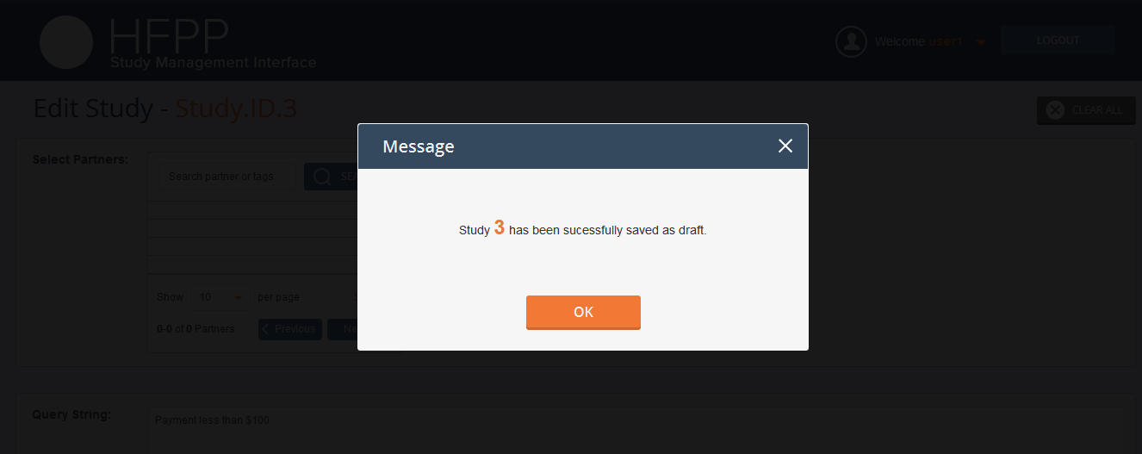
Go back to study list view, and open business rule view again
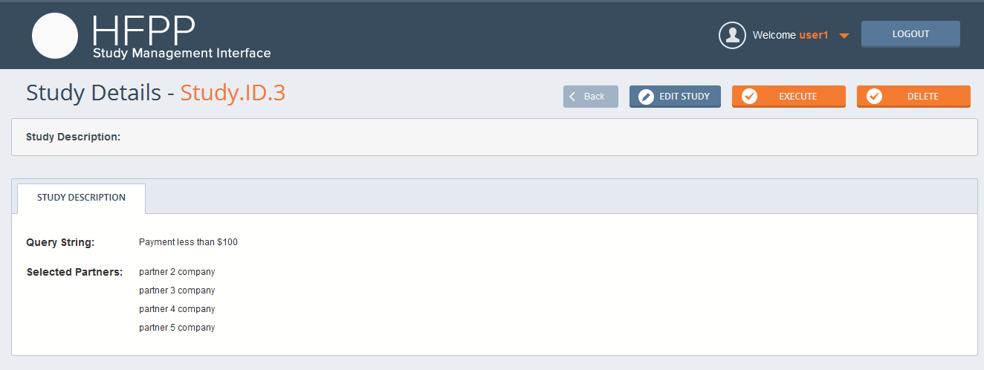
You could click “EXECUTE” to execute or ‘DELETE’ to delete it
Click the “IN PROGRESS” tab in study list view
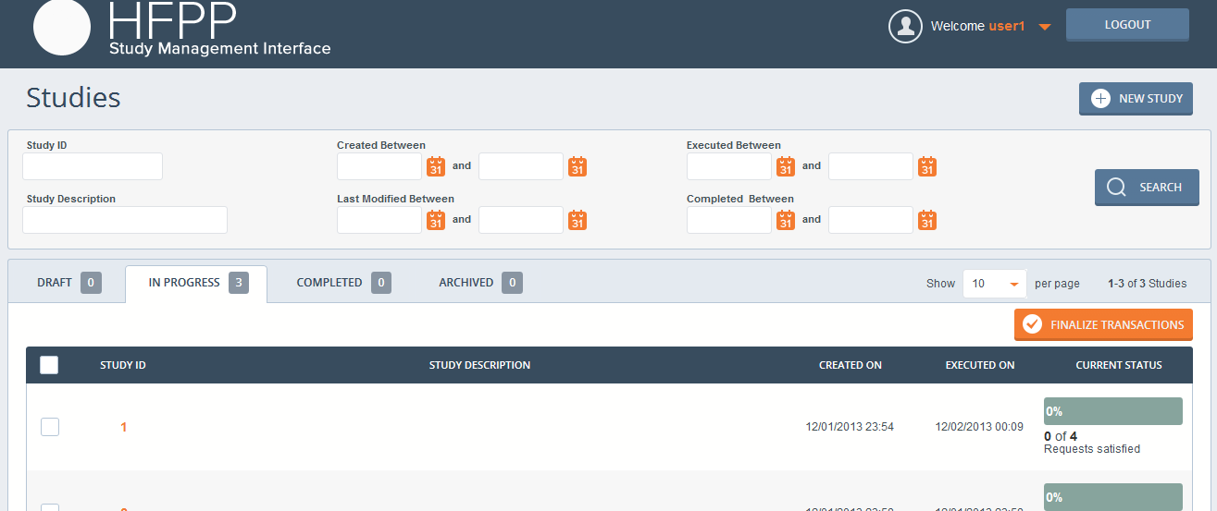
Open another console, run “curl -X GET http://localhost:8443/data_response” (make sure curl is installed) to trigger execute study response
Then refresh the study list view page
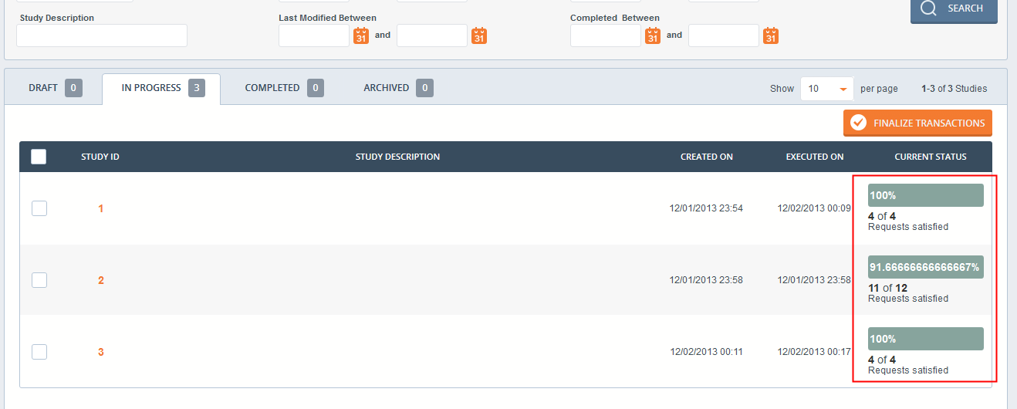
Click the study id under “IN PROGRESS” tab to view the transactions view
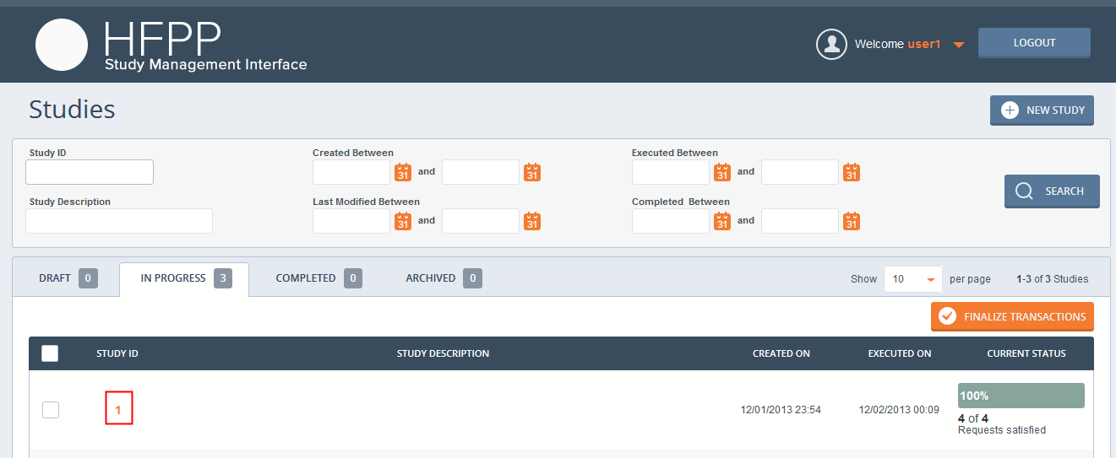
Input “1” in the search box and click “Search” button
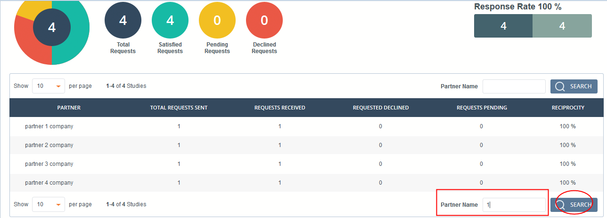

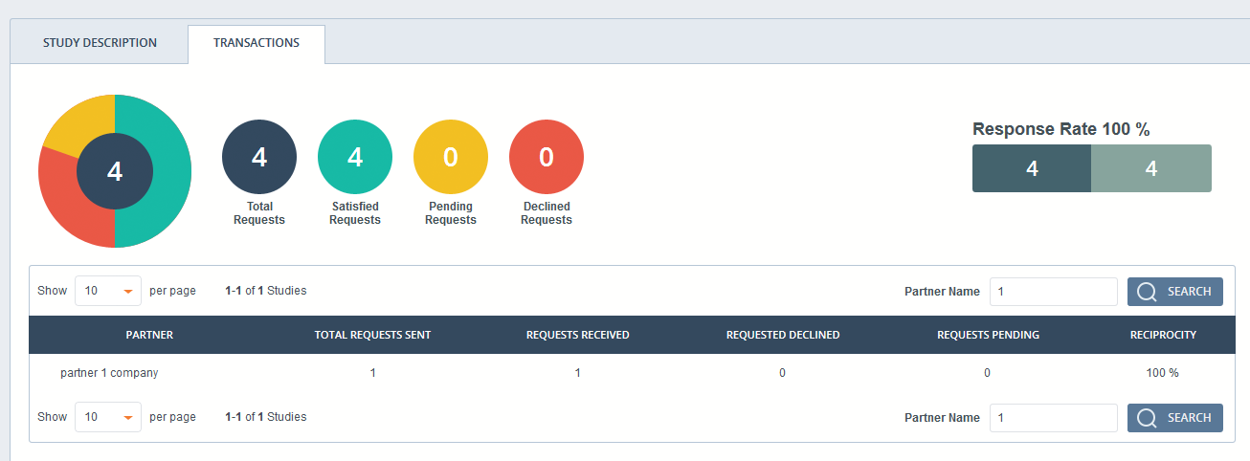
Change STUDY_FINALIZATION_JOB_INTERVAL back to the default value 60 in hfppnetwork/hfppnetwork/settings.py, then restart the study management server, wait a minute, you could see the server’s log, all the “In Progress” studies will be changed to “completed” then.
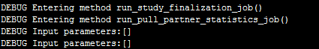
Go back the study list view
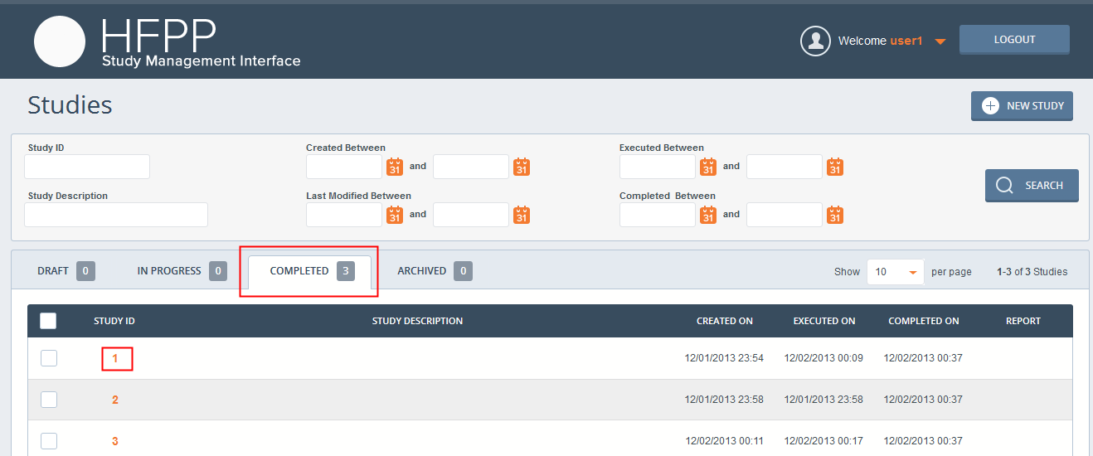
Click the study id of study 1, it will redirect to the results view
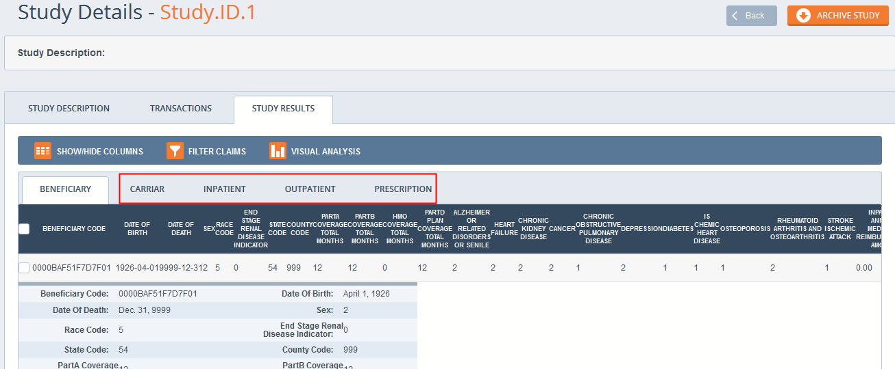
You could click other tables to view other type claim data
Click “Show hide/columns (columns are configured in CLAIM_DATA_FIELDS in hfppnetwork/hfppnetwork/settings.py)
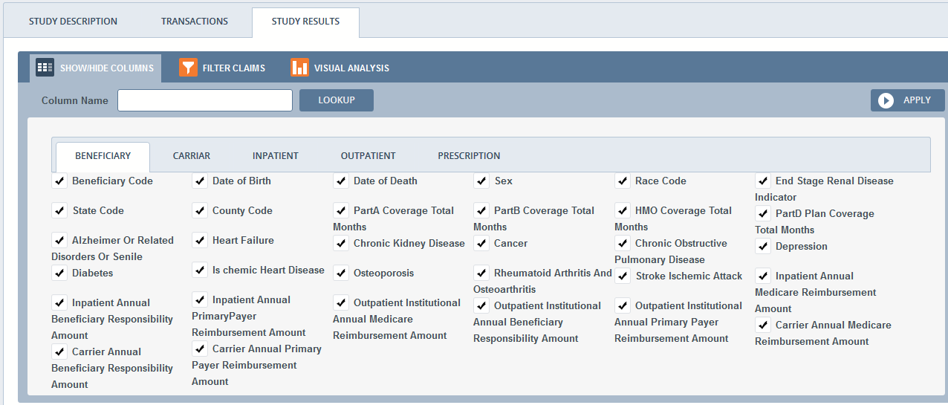Unselect “Date Of Birth” and “Date of Death”, click “APPLY”, then these two fields are not displayed in the table now(still in detail)
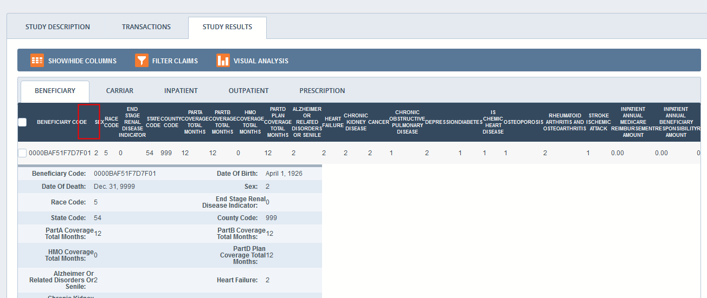
You could use the “LOOKUP” button to search fields locally, if you input nothing, it will show all the fields again.
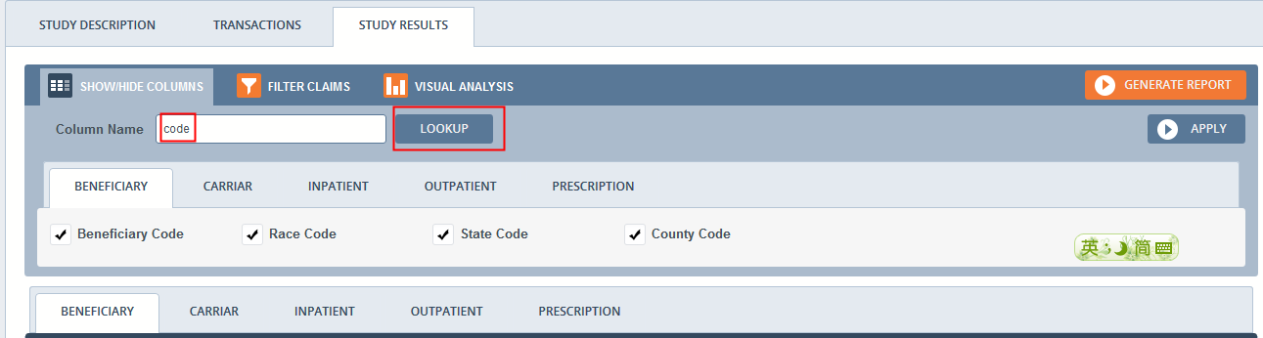
Filter Claim, you could click the “APPLY” button to apply the filter, however, as the rule editor is missing(not in scope) and query parser also missing(not in scope) in the server side, the result of “APPLY” is all the claim data now.
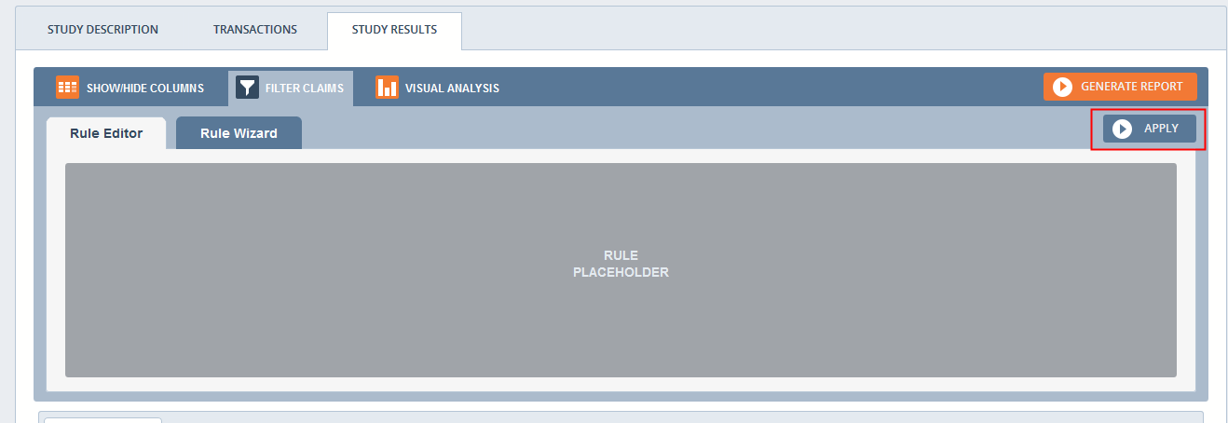
Click “VISUAL ANALYSIS” to create chart for current selected type of claim data
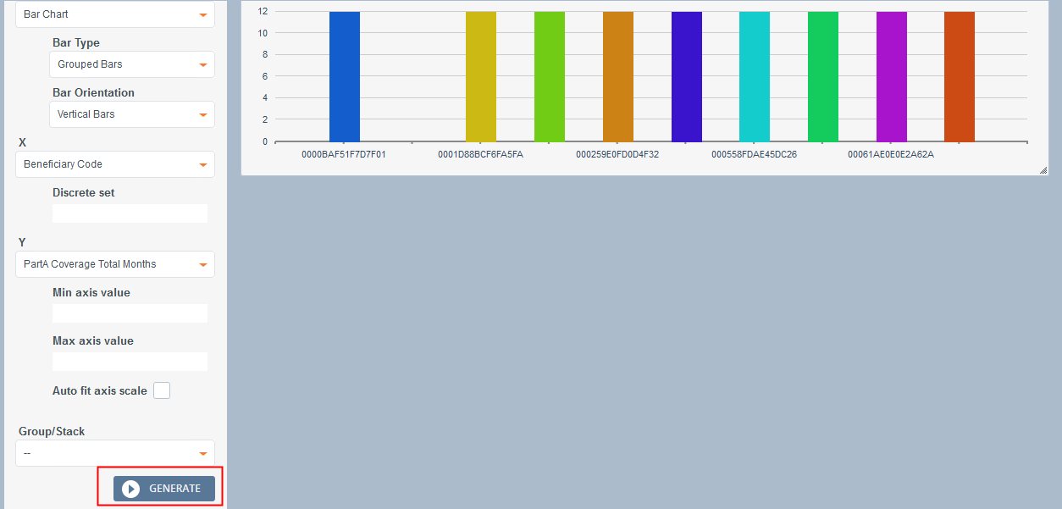
When you change claim data type, the x dimension, y dimension and group options will be changed to that kind of claim data’s selected fields, according to the visual analysis widget’s implementation, field of x dimension could be any type, field of y dimension should be float or integer, field of group should not be string.
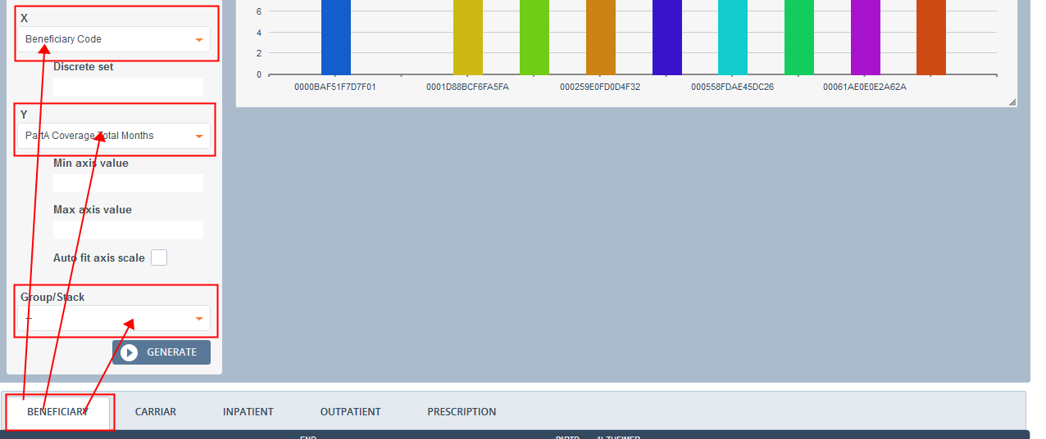
You could replace the page to verify that the study chart is saved in DB
You could click the “X” button on tab to delete the study chart
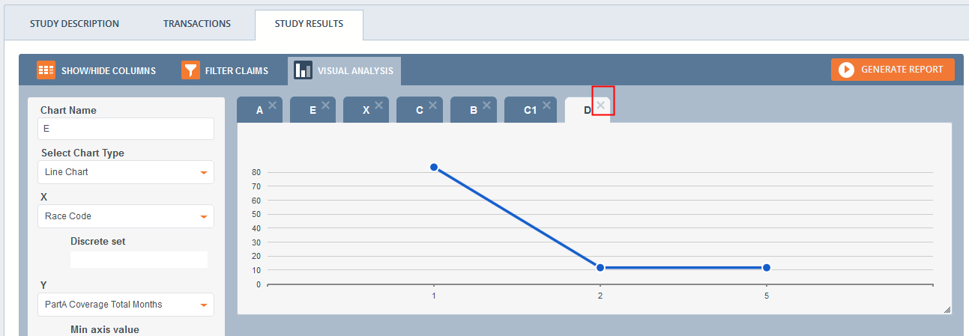
You could refresh the page to see the chart is really deleted from DB

Go back the results view of study 1, click “ARCHIVE STUDY”
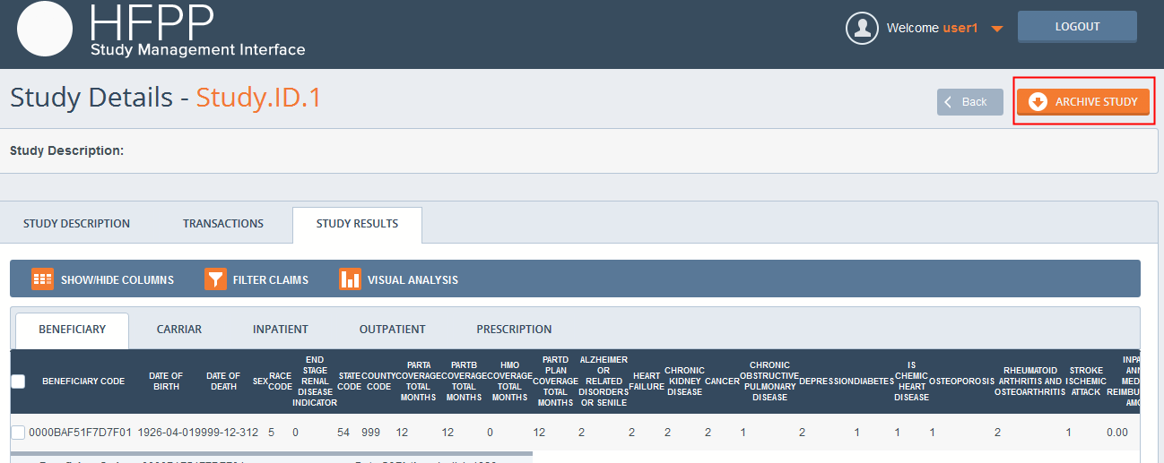
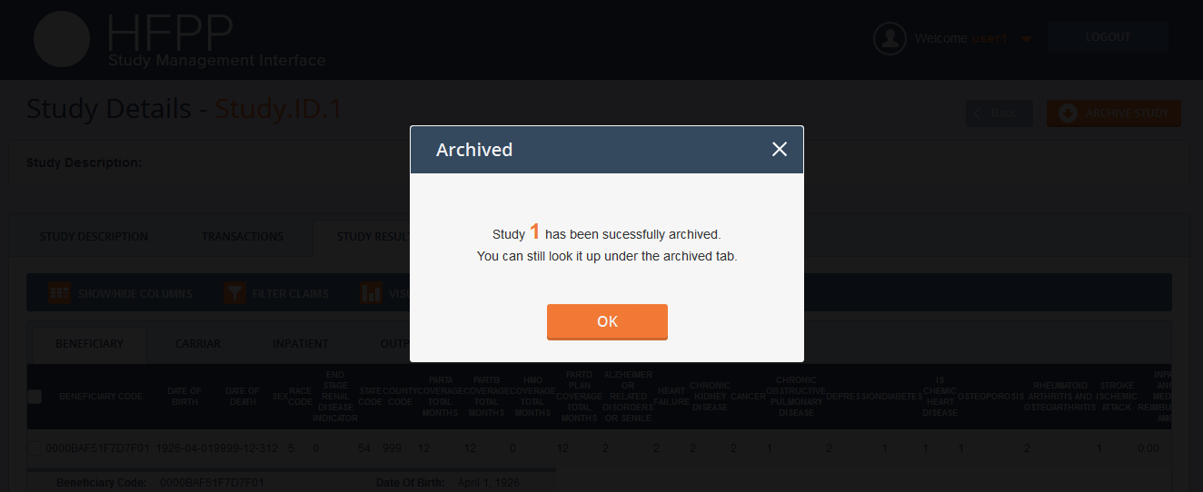
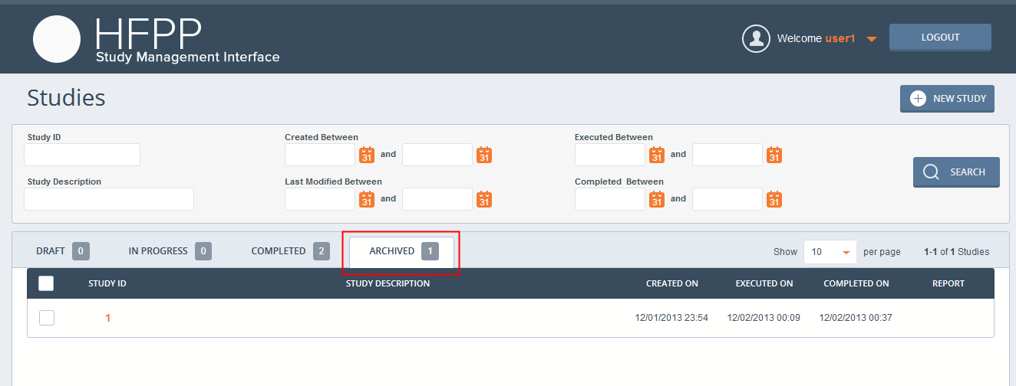
Go back to the results view of study 1
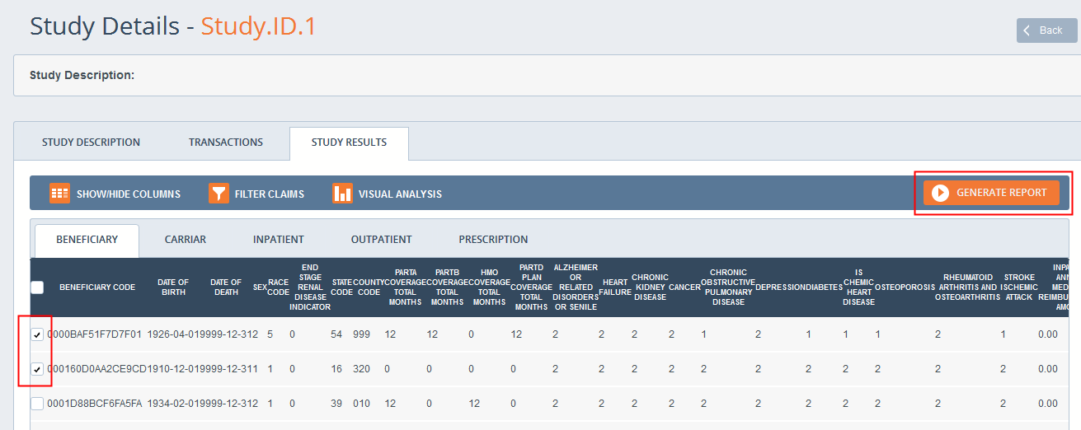
Select some rows in each tab, and click “GENERATE REPORT”
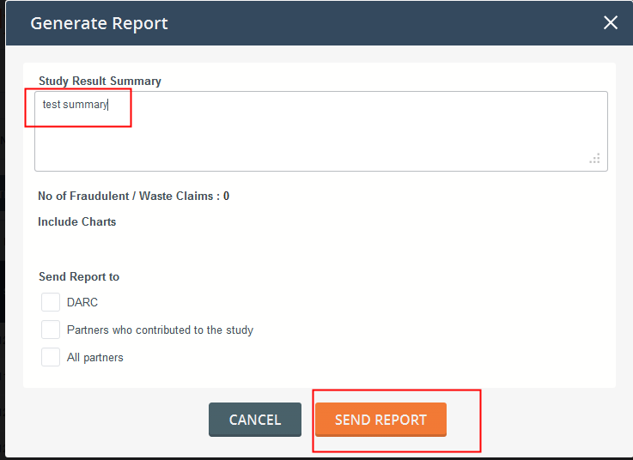
Input summary and click “SEND REPORT”
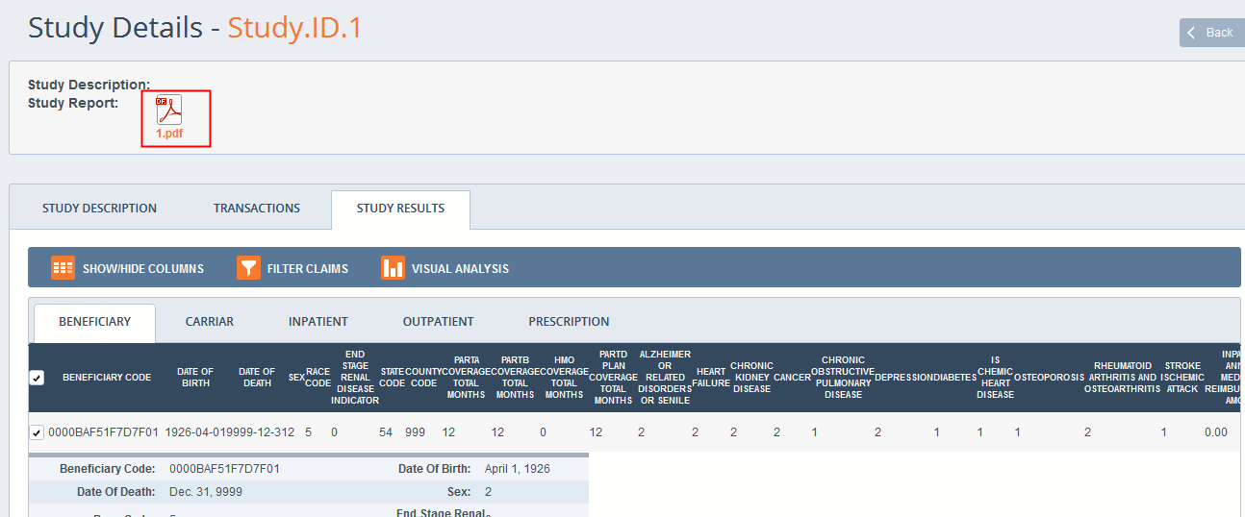
Click the pdf file to download, open it as following (as the template of report is not given, it just simply display the data as a demo)
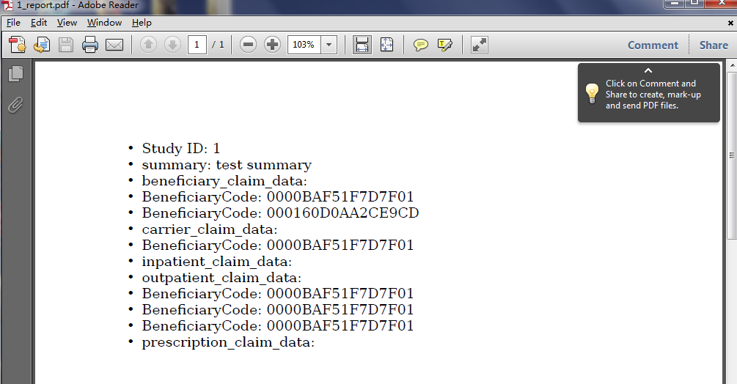

Go back the study list view, you could also download from list
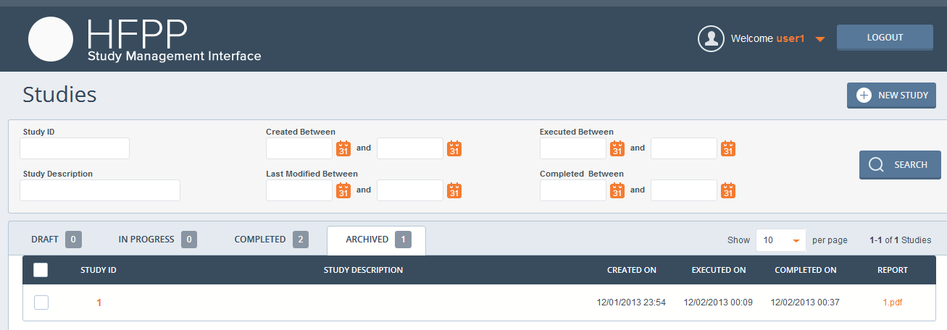

About search studies, please notice that the number in tab are total number of studies of each status(it is not affected by search conditions),

Resource Contact List

Name | Resource Email
TCSASSEMBLER

